[Your paper’s title starts here:
please center, use Times New Roman 14]

[Full First Author]¹*, [Full Second Author²], [Full Last Author³]
¹ [Full affiliation, including an address and the country]
² [Full affiliation, including an address and the country]
³ [Full affiliation, including an address and the country]

* Corresponding author
Author’s e-mails: [e-mail addresses for all of the Authors]
ORCID ID’s: [ORCID numbers addresses for all of the Authors, if possible]
- General conditions for submitting the papers
Original articles within the scope of the Journal should be submitted through Internet: https://cmms-edit.agh.edu.pl/index.php/journal/ as pdf file. Papers have to be submitted in English. The file with the paper should contain:
- Title, Authors – full names, affiliations, addresses, emails, and ORCID numbers of all authors.
- Abstract – it must state the main objectives, scope, and findings of the work within approximately 300 words.
- Keywords – a few keywords are required for use in indexing.
- Main text with figures.
- Acknowledgements (if necessary).
- Appendix (if necessary, not advised).
- References.
All contributions will be evaluated by the two reviewers selected by the Editorial Board and the Authors will be notified about the decision.
When the paper is accepted, MS Word source file with the text have to be sent. If requested by the editorial office also figures in separate files should be provided.
- Manuscript preparation
Text of the paper has to be written on the A4 format with 25 mm margins on all sides, using Times New Roman 12 pts font. Add page numbering at the bottom-centre of the page.

Equations should be justified to the left margin and the equation number (in parentheses) to the right margin:

$F\left(x\right)=a_{1}x-2y+β^{2}$ (1)

Figures and tables have to be included in the text. They should be referred to in the text by the whole word in lower case letters (for example, “function f(x) is presented in Figure 1, and the results of calculations are given in Table 1”). In a multi-panel figure, each component should be prepared and exported as an individual figure, then combined into a single layout. The panels must be labeled consecutively with lowercase letters a), b), c), etc., and the overall caption should describe the figure while referring to individual panels where appropriate.
Use the SI system for units and all quantitative data.

a) b)
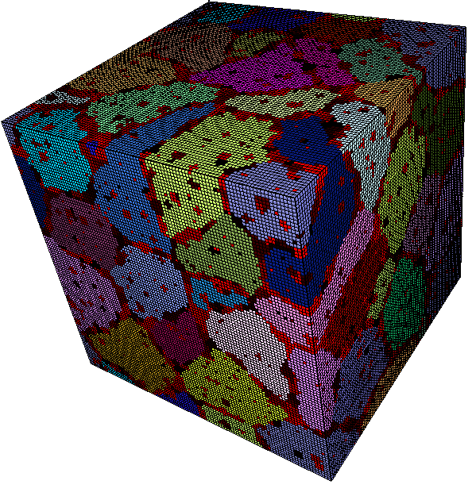
c) d)
Fig. 1. Example caption under the figure: a) …; b) …; c) …; d) …; e) …

When the paper is accepted for publication, the editorial office may also request that you provide figures in separate files.

Table 1. Please use the standard tables template from MS Word
Coefficient | Value | Minimum | Maximum | Average
α | 1.0 | 0.0 | 2.0 | 1.0
β | 1.0 | 0.0 | 2.0 | 1.0

- References
The references should be prepared in accordance with APA style guidelines: https://apastyle.apa.org/
https://apastyle.apa.org/style-grammar-guidelines/references/examples
The reference list is located at the end of the text.
The in-text references must be made by the name of the authors and the year of publication, for example:
In the case of one author:
…developed by Huber (1904).
…energetic criterion was applied (Huber, 1904).
In the case of two authors:
…on the basis of research performed by Sitko & Madej (2020).
…energetic criterion was applied (Sitko & Madej, 2020).
In the case of more than two authors:
Madej et al. (2019) researched the effect of...
…energetic criterion was applied (Madej et at., 2019).
In the case of referring to more than one publication, the alphabetical order is required:
(Perzynski & Madej, 2018; Sitko & Madej, 2014; Wang, 2020)
If one author of a group of authors published more than one cited paper in the same year, add letters a, b, c… after the year.
Examples of formatting references for books, journal publications and conference proceedings are presented below and follow the APA style. Name of the publisher as well as names of all editors have to be added for edited books or conference proceedings.

Journal papers
Author, A. A., Author, B. B., & Author, C. C. (Year). Title of article. Title of Periodical, volume number(issue number), pages. https://doi.org/xx.xxx/yyyy

Example:
Madej, L., Malinowski, L., Perzynski, K., Mojzeszko, M., Wang, J., Cios, G., Czarnecki D., & Bala P. (2019). Considering influence of microstructure morphology of epoxy/glass composite on its behavior under deformation conditions – digital material representation case study. Archives of Civil and Mechanical Engineering, 19(4), 1304–1315. https://doi.org/10.1016/j.acme.2019.07.001

Books
Author, A. A., & Author, B. B. (Year). Title of Work: Capital Letter also for Subtitle. Publisher Name. DOI (if available)

Example:
Pietrzyk, M., Madej, L., Rauch, L., & Szeliga, D. (2015). Computational Materials Engineering: Achieving High Accuracy and Efficiency in Metals Processing Simulations. Elsevier. https://doi.org/10.1016/C2013-0-00074-6

Conference papers
Author, A. A., & Author, B. B. (Year). Title of chapter or entry. In A. Editor, B. Editor, & C. Editor (Eds.), Title of Book (pages). Publisher. Chapter or entry DOI (if available)

Example:
Thompson, E. G., & Hamzeh, O. (1992). Quasi-steady-state analysis for radial forging. In M. Pietrzyk, J. Kusiak (Eds.), Proceedings of the Metal Forming Conference ‘92 (pp. 158–162). Elsevier.
- Proofs
The corresponding author will receive the galley proof. No new material may be inserted into the proofs.
- Copyright
For publication in the journal Computer Methods in Materials Science an article may not have been published previously anywhere else. Copyright of material in the article is the responsibility of the author. Extensive quotations and the sources of illustrations must be acknowledged.
After the acceptance of the manuscript by the Editorial Committee, the paper will be published as an open-access publication, which can be used, distributed, and reproduced in any medium according to the Creative Commons CC-BY 4.0 License requiring that the original work has been properly cited.
Simultaneously, there are no fees for the authors and the readers, which facilitates the widespread of the paper.
- Correspondence
All correspondence and inquiries should be sent to:
Anna Smyk (barana@agh.edu.pl)
Department of Applies Computer Science and Modelling
Faculty of Metals Engineering and Industrial Computer Science
AGH University of Krakow
al. A. Mickiewicza 30, 30-059 Krakow, Poland

